**A Omni Shop Ecommerce Solution**

1. Start Screen  
   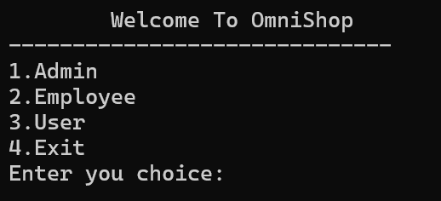
2. Admin Operations Screen

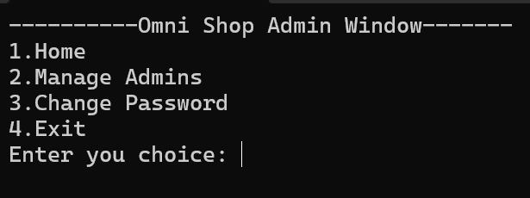

1. Admin Menu Screen  
   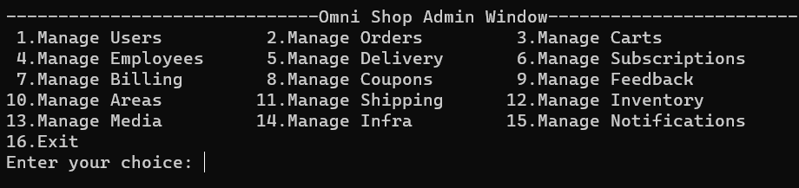
2. User Manager Screen  
   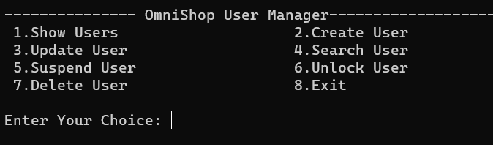
3. User Manager Show Screen  
   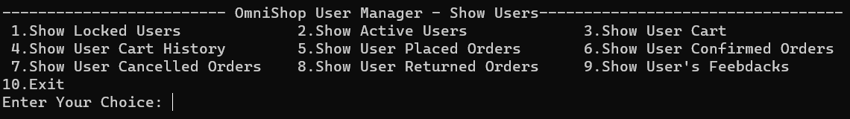
4. Order Manager Screen  
   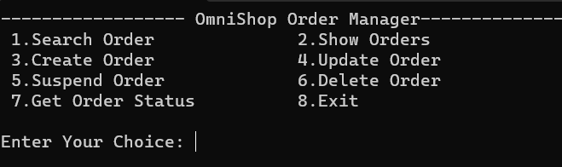
5. Order Manager Show Screen  
   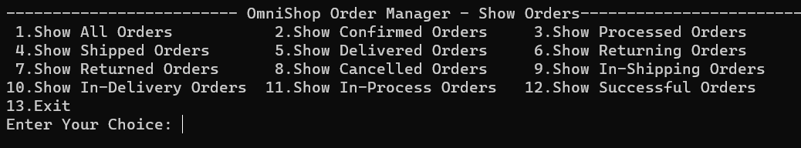
6. Cart Manager Scree  
   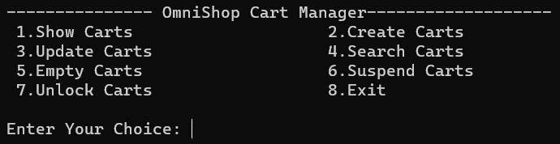
7. Cart Manager Show Screen  
   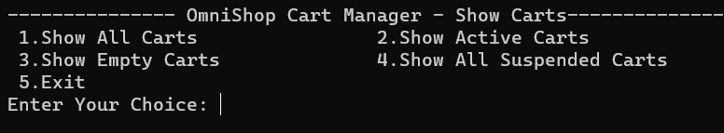
8. Form For Id Input  
   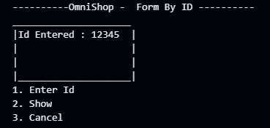
9. Form For Contact Number  
   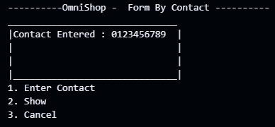
10. Form For User Name  
    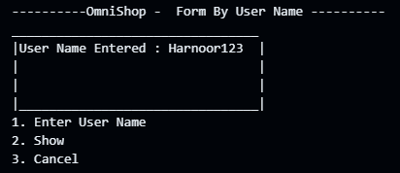
11. Form For Get Result By  
    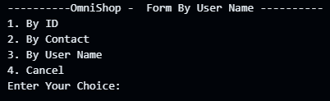
12. Form For Basic Filter  
    